Mahi Palimkar
231071036

Longest common subsequence
Positive test case 1

Positive test case 2

Positive tets case 3

Positive test case 4:

Negative test case 1:

Negative test case 2:

Negative test case 3:

Negative test case 4:

OUTPUTS:
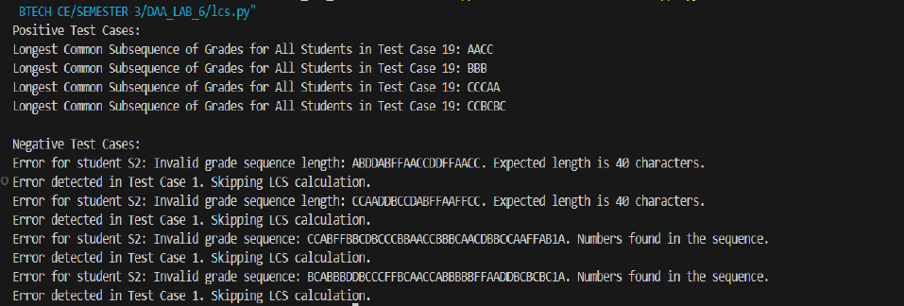

Matrix chain multiplication:
Input:

Output:
